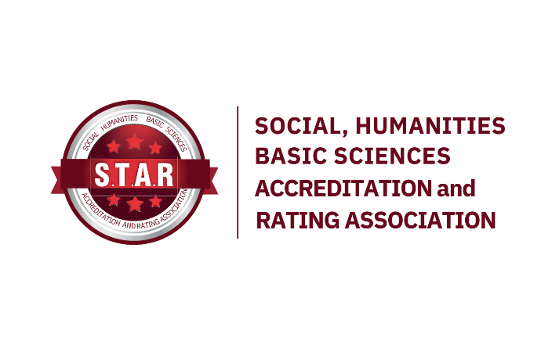

CONSISTENCY COMMITTEE DIRECTIVE

- Article: Basis, Purpose, and Scope
  - This directive has been prepared in accordance with the Working Regulations of the STAR Social and Human Sciences Accreditation and Rating Association.
  - The purpose of this directive is to regulate the duties and operational principles of the Consistency Committee.
- Article: Consistency Committee
  - The Consistency Committee is responsible for conducting consistency control checks on Evaluation Reports prepared by Evaluation Teams.
- Article: Duties of the Consistency Committee
  - The Consistency Committee reviews the Final Evaluation Report submitted by STARAK in the following aspects:
    - Consistency Across Years: By comparing the Final Evaluation Reports from previous years and the current year, the committee ensures that the assessment of similar deficiencies within a given standard remains consistent over time.

    - Internal Team Consistency: The committee verifies the consistency of findings related to deficiencies, weaknesses, concerns, and observations within the Final Evaluation Report, ensuring that the evaluation team assesses similar deficiencies within a given standard in a consistent manner.
    - Inter-Team Consistency: The committee checks the Final Evaluation Report for consistency in findings related to deficiencies, weaknesses, concerns, and observations across different evaluation teams, ensuring that program evaluations across different institutions within the same evaluation period maintain consistency in the assessment of similar deficiencies within a given standard.
    - Report Format and Content Consistency: The committee reviews the Final Evaluation Report for format, content, error, and stylistic consistency and prepares a Consistency Report for all consistency checks (Annex-1).
- Article: Operational Principles of the Consistency Committee
  - The Consistency Committee is accountable to the STAR Board of Directors.
  - The Chair of the Consistency Committee is responsible for the functioning of the committee.
  - The Chair of the Consistency Committee ensures all communication between the Consistency Committee, the STAR Board of Directors, STARAK, and the Evaluation Teams.
  - The Chair of the Consistency Committee ensures all communication among Committee Members.
  - The Consistency Committee convenes as necessary.
  - The agenda, date, location, and format (physical or online) of Consistency Committee meetings are determined by the proposal of the Committee Chair and mutual agreement of the Committee Members.
  - The Chair of the Consistency Committee submits the agreed-upon meeting details to STAR
  - If the Consistency Committee meets physically, the Chair submits the meeting minutes document to STAR. If the meeting is online, the digital meeting minutes are sent to STAR.
- Article: Procedure in Case of Conflict of Interest
  - Each committee member must act independently and impartially, taking potential conflicts of interest into account.
  - Committee members are required to immediately report any potential conflicts of interest related to the Final Evaluation Report of a Program to the committee.
  - In the case of a declared conflict of interest, the concerned member must withdraw from the evaluation and decision-making processes related to the application.
  - A reserve member, previously designated as an independent replacement, joins the committee in place of the withdrawn member.
  - All procedures related to conflicts of interest are recorded in accordance with the principles of transparency and accountability and shared with the applicant when necessary.
- Article: Amendments to the Directive
  - This directive is reviewed by the STAR Board of Directors.
- Article: Enforcement
  - This directive enters into force on the date of approval by the STAR Board of Directors.

ANNEX- 1 Consistency Report
Summary Information About the Undergraduate Program
The Council of Higher Education
Faculty
Undergraduate Program Name Language of Education
:
:
:
:

Internal Consistency Checks of the Evaluation Report | Consistent | Inconsistent
- Evaluation Report Prepared by the Evaluation Team;
In Terms of Format;
The Evaluation Report's structural consistency
The Evaluation Report's stylistic consistency
The Evaluation Report's grammar and compliance with spelling rules: The Evaluation Report's structural consistency, The Evaluation Report's stylistic consistency, The Evaluation Report's grammar and compliance with spelling rules, The use of correct and appropriate terminology in the Evaluation Report (including terms such as: Undergraduate Program Learning Objectives, Program Learning Outcomes, Program-Specific Criteria, Observations, Concerns, Weaknesses, Deficiencies, etc.)
- In Terms of Content;
Constructive criticism and feedback in the Evaluation Report
Deficiency levels assigned within the program based on evaluation criteria
Compliance of the Evaluation Report with the specified criteria
Comparison with other Evaluation Reports | Consistent | Inconsistent
Balance in the evaluations presented in the report
Appropriate use of terms such as deficiency, weakness, concern, and observation in relation to evaluation criteria
Consistency between; The Evaluation Report, The Self-Assessment Report and its annexes, Evidence and information obtained during the On-Site Visit
The level of reporting for similar deficiencies identified within the same criteria (deficiency, weakness, concern)
Ensuring that the findings and conclusions in the Evaluation Report are presented objectively without exaggeration or excessive criticism, while including constructive feedback
Ensuring that the Evaluation Report is free from personal opinions and that findings are supported by evidence
Explanations
- Evaluation Report Prepeared by the Evaluation Team;
- In terms of Content;
- Conclusion;
Consistency Committee Members
Chair Member Member

¹ (If the language of education is English, the percentage should be specified.)

